Job Sheet
- Logo change to a new design
- Create by → should be refers to username x
- Eye Mark → changes done not updated in Job order and Job sheet print-out x
- Unit size V x H → H value is not correct. Example: user entered 2200 but in the printout the value become 2.20 x

Job Sheet – Parameter.
- Cylinder number and Pricing column not needed in the Job Sheet print out. x
- Rename Cust Cyl ID to Cust Cyl No (standard name now) x
- Cust Steelbase ID column not appeared in the Job sheet print out. x
- Status column should refers to 1) common 2) Existing 3)Matching 4) Engraving 5) De/rechrome fields. x
- Diameter → missing decimal number. Example 413.80 appeared as 413.8 x

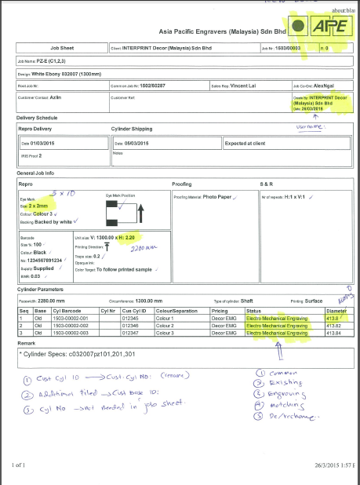

Engraving protocol
- New Logo
- Unit size horizontol – wrong value even user update to a new value in job order.
- Actual copper and Chrome column → leave it blank.
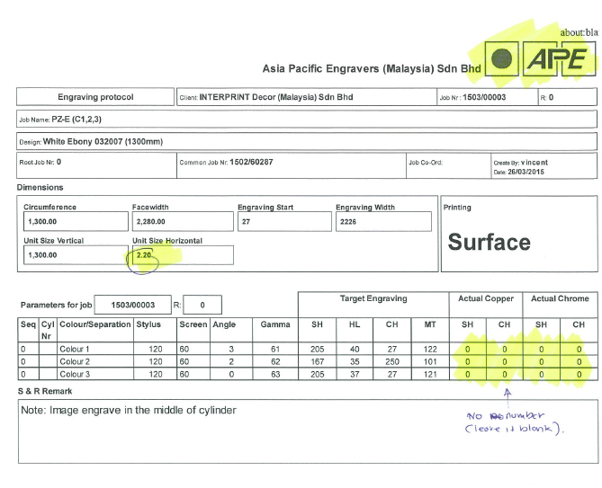
- Rename Cancel to Return
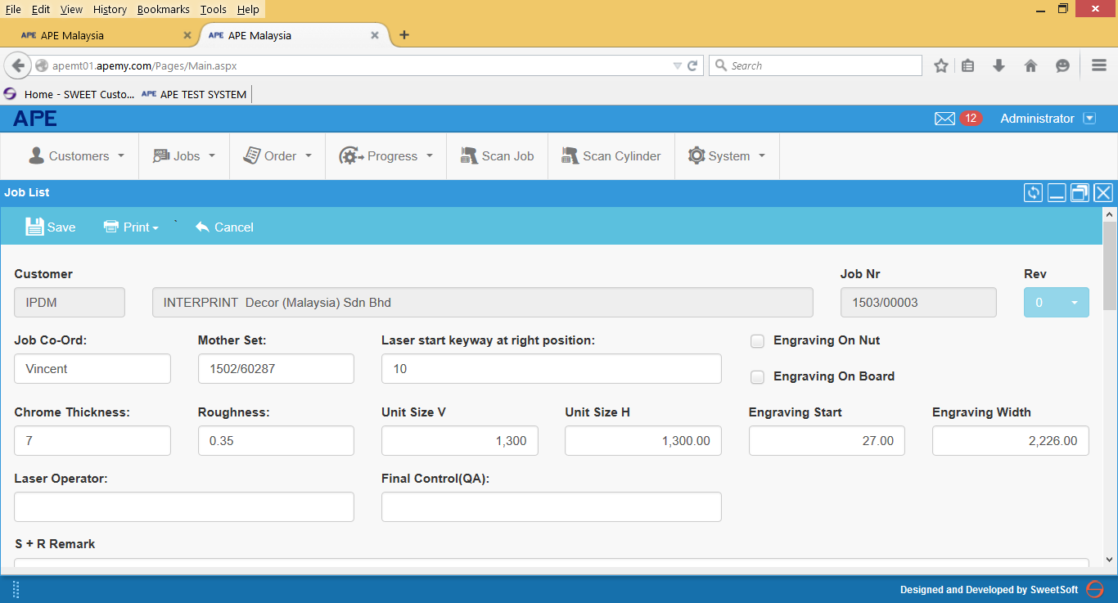

Cylinder Card
- New Logo
- Internal cylinder No → Not needed in the printout
- Rename Cust Cyl ID to Cust. Cyl No (Standard Name)
- Add Cust Steelbase ID in the printout
- Cylinder status not appeared in the print out.
- Please make the specified cylinder sequence font size bigger, bolded and with background colour in the cylinder card printout.
Example:

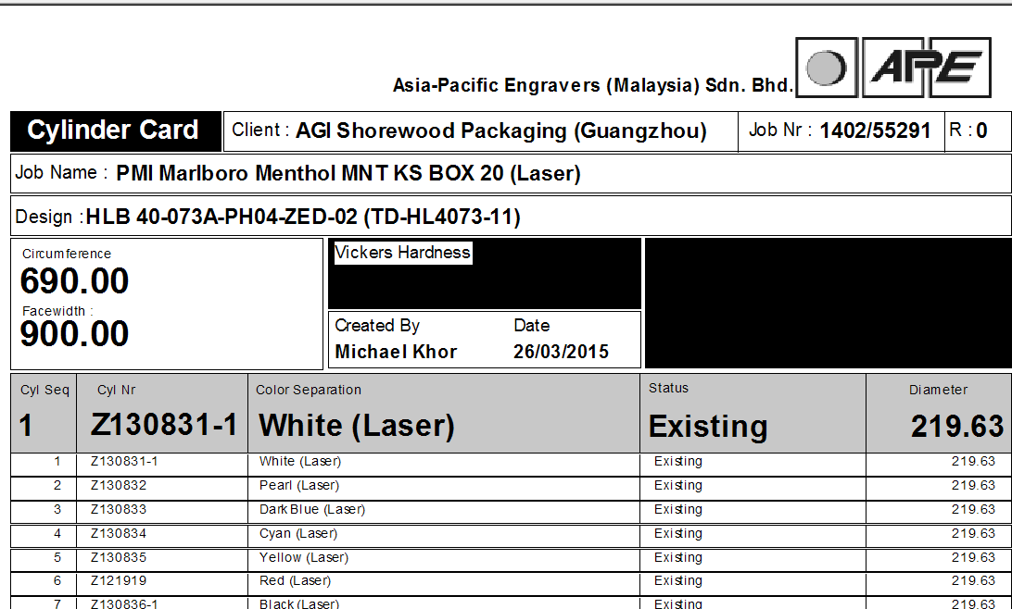

- Printout for each cylinder card must be separated and fit into 1 A5 size paper. Currently, the printout of all cylinder card appeared in one sheet and there is cut-off in the printout.
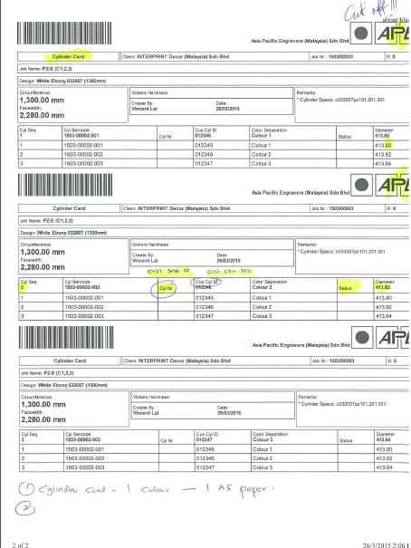

Order Confirmation / DO / Invoice
- Unable to create OC / DO and Invoice for all of the Job Order created. Encountered Error 404 below. However I am able to create OC /DO and Invoice for for 1 job only (Job Order 1503/00005)
- Example: Create New OC for Job No 1503/00006. If I tried to do the OC in the Database server itself, there is no error message but just cannot proceed with creation of OC

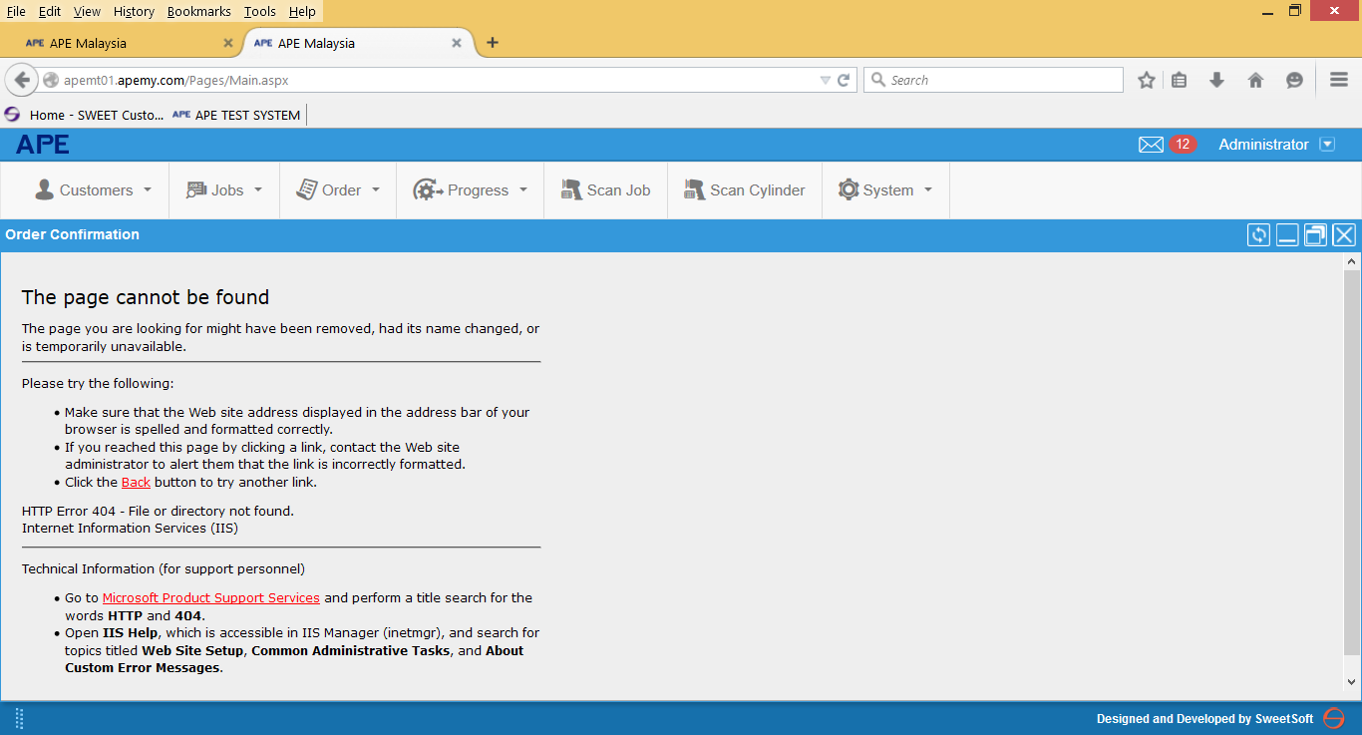

Order Confirmation for Job 1503/00005 (succesfully created)
- Number / date column refers to the wrong field.
Number / Date : → 115100001 / 26.03.2015
APE Order No / Date: → 1503/00005 / 03.03.2015
- Terms of Payment and Terms of delivery location margin issue.
- Cyl. Barcode column – not needed
- Cylinder ID / Product ID – not needed
- Cust Cylinder ID → Rename to Cust. Cyl. No.
- Cust Steelbase ID → Needed in the printout
- Steelbase Column → Old or New instead of 0 or 1
- Description column → bigger space needed
- Description data – Only Colour and status needed eg. Blue Engraving and not “Blue Tobacco Engraving”
- 2 decimal points for width and circumference e.g. 180.00
- GST at → Need the percentage e.g. GST at 6 %
- Alignment for additional charges value -> not aligned with the rest.

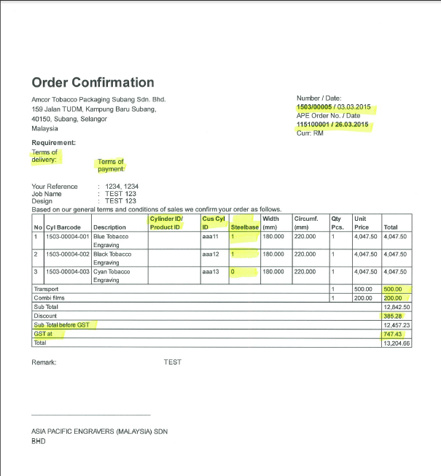

Delivery Order
- Create spacing between Malaysia and Your Reference
- Cyl barcode and Cyl No. columns → Not needed in the printout
- Cust Cyl ID → rename to Cust Cyl No.
- Add Cust Steelbase ID column
- Rename Gross weight → Gross Weight (kg)
- Rename Net weight → Net Weight (kg)

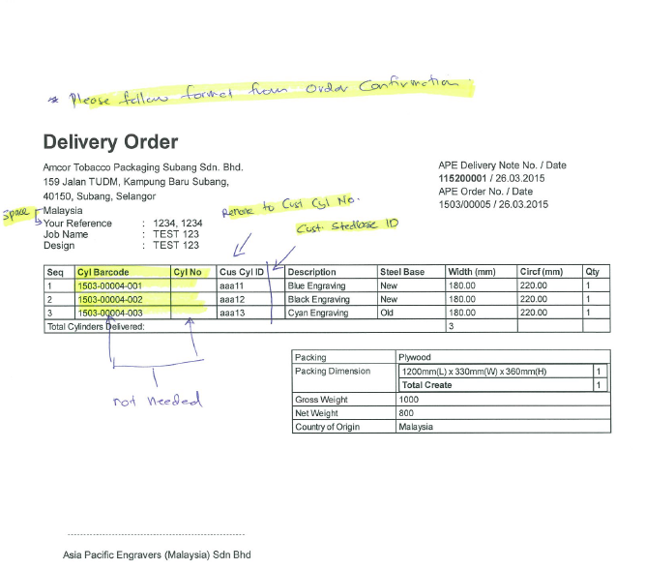

TAX INVOICE
- Customer Name appeared twice
- TIN NO → Not Needed
- Ship to Address → Full Name and Address.
- Same line for Delivery no. and date
- Same line for Order no. and date.
- Cyl Barcode → not needed
- Cyl ID → Not needed
- Rename Cust Cyl ID → Cust Cyl No. (Standard Name)
- Add Cust Steelbase ID column.
- 2 decimals for Width and Circumference
- GST at 6 %
